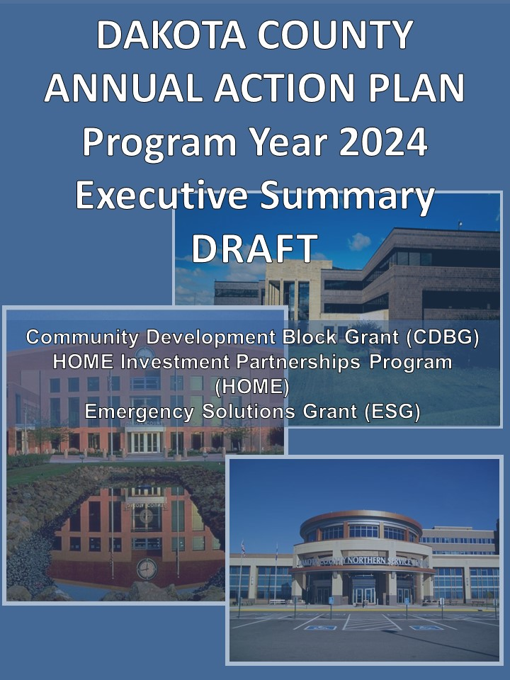

Executive Summary

AP-05 Executive Summary - 91.200(c), 91.220(b)
1. Introduction
In order to receive federal funding from the U.S. Department of Housing and Urban Development (HUD), Dakota County is required to prepare a Consolidated Plan, as well as subsequent Annual Action Plans and Consolidated Annual Performance and Evaluation Reports (CAPERs), for the following entitlement programs: Community Development Block Grant (CDBG); HOME Investment Partnerships Program (HOME); Housing Opportunities for Persons with AIDS (HOPWA) and Emergency Solutions Grant (ESG). Currently, Dakota County does not receive any HOPWA funds.

The Fiscal Year (FY) 2024 Annual Action Plan (Action Plan) is the fifth year of Dakota County’s Consolidated Plan for Fiscal Years 2020-2024 (Con Plan) as ratified by the Dakota County Board of Commissioners and approved by HUD.

The Con Plan lays out the objectives, priority goals and outcomes Dakota County has established to provide decent affordable housing, suitable living environments, and expand economic opportunities principally for low-and moderate-income households over the next five-year period. In the Action Plan, Dakota County identifies the proposed programs and projects to be undertaken during the 2024 program year to achieve the objectives and outcomes established in the Con Plan.

The CDA has administered the federal funds on behalf of Dakota County since the County became an entitlement jurisdiction in 1984. Each of the three entitlement programs has eligible activities in which the funds can be utilized. The CDA is charged with ensuring the requirements are met and will continue to provide the administrative guardianship of all three programs through its agreement with the County.

Dakota County is designated as the lead agency for the Dakota County HOME Consortium and assumes the role of monitoring and oversight of the HOME funds for the Consortium, which includes the counties of Anoka, Dakota, Ramsey, and Washington, and the city of Woodbury. As the grantee of CDBG funds, Dakota County works directly with the various municipalities (municipal subrecipients) within the County to provide access to this funding stream. The CDA provides managerial oversight of the numerous activities implemented with HOME, CDBG, and ESG resources.

2. Summarize the objectives and outcomes identified in the Plan
This could be a restatement of items or a table listed elsewhere in the plan or a reference to another location. It may also contain any essential items from the housing and homeless needs assessment, the housing market analysis or the strategic plan.

With the outcomes established by Congress in mind and guided by the mission statements of Dakota County and Dakota County CDA, the following objectives were identified to achieve the housing and community development needs of Dakota County communities and its residents.

- Increase the affordable housing choices for low-and moderate-income households.
- Preserve and improve existing housing to maintain affordability.
- Increase access and quality of living by providing public services and supporting public facilities.
- Support community development that revitalizes neighborhoods and removes safety and blight hazards.
- Support economic development that enhances the workforce and businesses.
- Support planning efforts that address the housing, community and economic development needs of Dakota County and continue to foster partnerships with community stakeholders.

The priority goals and the strategies to achieve the desired outcomes of decent housing, suitable living environments and economic opportunity were then formulated to serve the broad range of households, and to provide benefit to as many persons possible given the parameters of the funding programs.

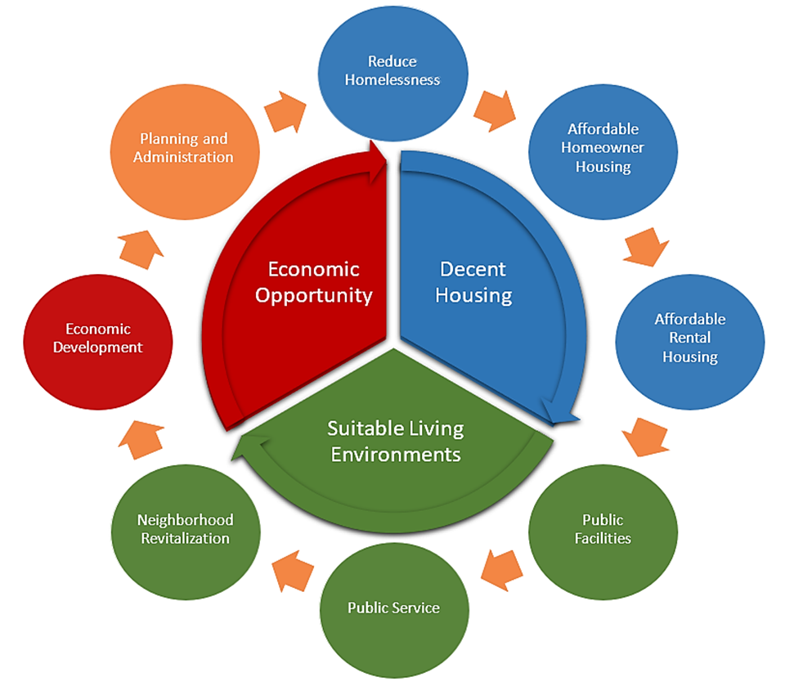
The following chart details the strategies from the 2020-2024 Consolidated Plan.
2020-2024 Consolidated Plan - Dakota County
Objective |  |  |  | Priority | Strategy |  | Outcome
6 | Support planning efforts that address the housing, community and economic development needs of  Dakota County and continue to foster partnerships with community stakeholders. | 1 | Increase the affordable housing choices for low-and moderate-income households. | Reduce Homelessness | a. Support the implementation and operation of coordinated access entry sites for families, youth and singles  b. Support housing stabilization initiatives for homeless populations  c. Support the operation of emergency shelter facilities | Planning and Administration  a. Support all of the goals and strategies with planning and administration | • 200 Households provided Rapid Re-housing Assistance  • 100 People assisted with Homeless Prevention initiatives
 |  |  |  | Affordable Rental Housing | a. Assist households to secure housing through new construction  b. Improve energy efficiency of rental units  c. Rehabilitate and preserve affordability in multifamily units  d. Support fair housing activities |  | • 360 Rental Units constructed  • 20 Rental Units rehabilitated
 |  | 2 | Preserve and improve existing housing to maintain affordability.
 |  |  |  | Affordable Homeowner Housing | a. Increase supply of affordable homeowner housing  b. Improve energy efficiency of owner-occupied housing units  c. Rehabilitate and preserve affordability in single family units  d. Support fair housing activities |  | • 300 Homeowner Units rehabilitated  • 6 Homeowner Units (re)constructed
 |  | 3 | Increase access and quality of living by providing public services and supporting public facilities. | Public Facilities | a. Assist in the development of centers and recreational parks  b. Assist LMI homeowners with street assessments  c. Improve accessibility for Public Facilities in compliance with ADA  d. Improve sidewalk accessibility and safety in compliance with ADA |  | • 13,000 Persons benefited from public facility or infrastructure improvement
 |  |  |  | Public Services | a. Support programs that fulfill basic needs (food and shelter) for people who are low-income and/or homeless  b. Support programs for youth  c. Support programs for seniors  d. Support transportation services |  | • 15,000 Persons benefited from public services
 |  | 4 | Support community development that revitalizes neighborhoods and removes safety and blight hazards.
 |  |  |  | Neighborhood Revitalization | a. Address vacant or substandard properties that may or may not be suitable for rehab  b. Address water and sanitation hazards  c. Address contamination clean up issues |  | • 150 Households assisted  • 3 Buildings demolished
 |  | 5 | Support economic development that enhances the workforce and businesses. | Economic Development | a. Support work initiatives that assist residents to access living wage jobs  b. Support initiatives that help low-income people gain work skills, jobs, and employment history  c. Provide financial assistance to businesses to address building deficiencies (exterior façade improvements) |  | • 20 Workforce Trainees

3. Evaluation of past performance
This is an evaluation of past performance that helped lead the grantee to choose its goals or projects.
Dakota County and the Dakota County HOME Consortium consistently perform well in the administration of the three grant programs discussed in this Plan. In the CDBG program, one regulatory measure used by HUD to evaluate performance is the timeliness ratio test. This formula measures the amount of an entitlement community’s unexpended funds 60 days prior to the start of the next program year in relation to the amount of funding it receives; the ratio cannot exceed 1.5. Dakota County’s timeliness ratio is measured on May 2nd each year. On February 6, 2024, the Dakota County ratio was 1.27.

The HOME program uses commitment and expenditure deadlines to measure performance. Dakota County has met all deadlines.

The ESG program uses drawdown requirements to measure performance. Dakota County has made consistent drawdowns of ESG funds.

While these financial tests are required and are measurements of performance, it is also important that projects and programs carried out with these funds meet outcome expectations and benefit eligible persons. Reporting on outcomes and beneficiaries is made available each year in the Consolidated Annual Performance and Evaluation Report (CAPER). Dakota County and the CDA recognize that the evaluation of past performance is critical to ensuring the County and its subrecipients are implementing activities effectively and that those activities align with the overall strategies and goals listed in the Con Plan. The performance of programs and systems are evaluated on a regular basis.

4. Summary of Citizen Participation Process and consultation process
Summary from citizen participation section of plan.
The development timeline and process of the Action Plan was discussed at the annual CDBG workshops held on November 16, 2023. These workshops are for municipalities and townships to help them with the CDBG application process and to better understand the rules of the CDBG program. Each municipality is required to formally apply for CDBG funding and request funding for activities that would best serve their community needs. Applications were provided to city and township staff on November 16, 2023, and were required to be submitted to the CDA by January 19, 2024.

CDA staff regularly attend the monthly meetings held by the Affordable Housing Coalition and consulted the members of the coalition regarding the Annual Action Plan. The discussion and feedback were helpful to determine the actions needed to meet the goals of the Con Plan. Members of the Affordable Housing Coalition also reviewed and made comments on the ESG Written Standards. These comments will be incorporated into the Written Standards prior to the Action Plan public hearing on April 23, 2024.

CDA staff consulted with following Dakota County departments and divisions: Community Services, Physical Development, Workforce Development, Environmental Resources, and the Office of Planning specific to the activities that could be potentially funded with CDBG funds. An internal e-mail was sent to various County Departments to apply for 2024 funding with the same application deadline as the municipalities. The Physical Development Committee of the Whole reviewed the staff-recommended 2024 Countywide activities on February 20, 2024.

To continue the community engagement process once the proposed objectives and outcomes had been identified, CDA staff presented the plan to the community and its stakeholders in the following manner:

- Presentations (February 2024-May 2024) – The Dakota County CDA presented a draft of the priorities and the established goals at the following venues:
- A Consortium-wide presentation to the public (January 29). No members of the public attended.
- The Affordable Housing Coalition reviewed the ESG activities at a regularly scheduled meeting (February 8).
- The Physical Development Committee of the Whole will review the Action Plan at a regularly scheduled meeting (March 19).

- Public Hearing and Comment Period (March 2024 – April 2024) – A 42-day public comment period was opened on March 8, 2024, and will run through April 19, 2024. Public notices will be published in the Dakota Tribune and the Star Tribune, as well as on the websites of Dakota County, the Dakota County CDA, and the cities in Dakota County (only the public hearing notice will be posted on cities’ websites). A public hearing will be held on April 23, 2024 at the Dakota County Board of Commissioners meeting. The Dakota County HOME Consortium members each hold their own public hearings.

5. Summary of public comments
This could be a brief narrative summary or reference an attached document from the Citizen Participation section of the Con Plan.
A public meeting that included all HOME Consortium members was held on January 29, 2024. No members of the public attended. The public hearing for the Dakota County Action Plan will be April 23, 2024. The public comment period will be open for a period of 42 days.

6. Summary of comments or views not accepted and the reasons for not accepting them
No comments were received from the public meeting on January 29, 2024. The public hearing is slated for April 23,2024.

7. Summary
HUD has yet to release the federal budgets for FY 2024. The following estimated budgets are based on the FY 2023 grant amounts, per HUD guidance. Dakota County and the HOME Consortium members anticipate being allocated approximately $4.76 million between CDBG, HOME and ESG for FY 2024 based on what was received in FY 2023. Dakota County is expected to receive a little over $3 million in grant allocations, with the largest being CDBG.

For the 2024 program year, Dakota County has set funding for 38 activities to take place either within a specified city or on a Countywide basis. The breakout is 30 activities are funded with CDBG, five activities are funded with ESG, and three activities are funded with HOME including program administration. The following activity statement and graphs detail the intended uses (activities) of CDBG, HOME and ESG funds for FY 2024. Below is the contingency plan for FY 2024.
- CDBG: Most CDBG activities will be increased or decreased proportionally depending on the final FY 2024 allocation with the following exceptions. Note that public service activities will not exceed the statutory limit of 15 percent of the total CDBG allocation.
  - The Countywide home improvement loan activity will be decreased if the CDBG allocation is less than the estimate. All Countywide activities will be increased proportionally if the CDBG allocation is increased, except the administration activities which will be held to the proposed levels.
- HOME: All HOME activities will be proportionally increased or decreased based on the final HOME allocation received from HUD, except the CHDO activities will remain at 15 percent of the total HOME allocation.
- ESG: If additional ESG funds are received, funds will be added to the HMIS and Administration activities, subject to statute limits. If funds are reduced, the Emergency Shelter, Homelessness Prevention, and Rapid Rehousing activities will each be reduced by the percentage of the decreased grant amount.

The other members of the Dakota County HOME Consortium will work with their respective elected Boards for approval of the non-HOME funds.

DRAFT Dakota County FY 2024 CDBG/HOME/ESG Activity Statements

DRAFT FY 2024 Dakota County CDBG Activity Statement
Large Cities:
City | Project | 2024 Estimated Budget
Apple Valley | Home Improvement Loan Program | $ 178,254
 | Public Service - DARTS Senior Chore Service | $ 31,456
 | Total | $ 209,710

City | Project | 2024 Estimated Budget
Burnsville | Home Improvement Loan Program | $ 191,516
 | Public Service - Burnsville Youth Collaborative | $ 63,000
 | Total | $ 254,516

City | Project | 2024 Estimated Budget
Eagan | Home Improvement Loan Program | $ 145,010
 | Public Service - Pre-School Program | $ 10,000
 | Public Service - Youth After School Programs | $ 10,000
 | Public Service - DARTS Senior Chore Services | $ 5,000
 | Public Service – Dakota Woodlands Youth | $ 12,000
 | Public Service - Senior Services | $ 3,000
 | Total | $ 185,010

City | Project | 2024 Estimated Budget
Farmington | Home Improvement Loan Program | $ 33,578
 | Public Service - Senior Services | $ 5,000
 | Total | $ 38,578

City | Project | 2024 Estimated Budget
Hastings | Assessment Abatement | $ 70,369
 | Total | $ 70,369

City | Project | 2024 Estimated Budget
Inver Grove Heights | Home Improvement Loan Program | $ 86,430
 | Total | $ 86,430

DRAFT Dakota County 2024 CDBG Activity Statement Cont’d.

City | Project | 2024 Estimated Budget
Lakeville | Home Improvement Loan Program | $ 58,284
 | Planning & Admin – Economic Development Plan | $ 17,485
 | Public Service - Senior Transportation | $ 25,000
 | Public Service - Senior Services | $ 15,798
 | Total | $ 116,567

City | Project | 2024 Estimated Budget
Mendota Heights | Home Improvement Loan Program | $ 18,276
 | Total | $ 18,276

City | Project | 2024 Estimated Budget
Northfield | Public Service - Downpayment Assistance | $ 26,738
 | Housing Rehabilitation Program | $ 49,657
 | Total | $ 76,395

City | Project | 2024 Estimated Budget
Rosemount | Home Improvement Loan Program | $ 50,026
 | Total | $ 50,026

City | Project | 2024 Estimated Budget
South St. Paul | Home Improvement Loan Program | $ 57,076
 | Total | $ 57,076

City | Project | 2024 Estimated Budget
West St. Paul | Home Improvement Loan Program | $ 92,504
 | Total | $ 92,504

DRAFT Dakota County 2024 CDBG Activity Statement Cont’d.

Countywide | Project | 2024 Estimated Budget
Dakota County | Home Improvement Loan Estimated Revolving Loan | $ 400,000
 | Planning & Admin - CDA General Grant Administration | $ 235,416
 | Countywide Home Improvement Loan | $ 290,649
 | Countywide Well Sealing Grants | $ 30,000
 | Countywide Septic System Repair/Replacement Grants | $ 60,000
 | Planning & Admin – Fair Housing Activities | $ 3,000
 | Public Service - Housing Counseling | $ 87,278
 | FY2024 CDBG Total Estimated Budget | $ 1,961,800
 | FY2024 CDBG Countywide | $ 467,927
 | FY2024 CDBG Grant Administration | $ 255,901
 | FY2024 CDBG Estimated Budget w/ estimated RL | $ 2,361,800

DRAFT FY 2024 Dakota County HOME Consortium Activity Statement

Participating Jurisdiction | Project | 2024 Estimated Budget
Anoka County  23.42% Share | Affordable Rental Housing | $ 462,101.07
 | Affordable Rental Housing (from Woodbury) | $ 87,605.84
 | Affordable Rental Housing Program Income | $ 240,747.87
 | Affordable Rental Housing Program Income (from Woodbury) | $ 2,175.99
 | Community Housing Development Organization - Rental | $ 92,420.21
 | Grant Administration | $ 49,970.69
 | Grant Administration – Program Income | $ 20,062.33
 | Total | $ 955,084.00

Participating Jurisdiction | Project | 2024 Estimated Budget
Dakota County  36.50% Share | Affordable Rental Housing | $ 720,183.14
 | Rental Housing – Program Income | $ 54,678.56
 | Community Housing Development Organization - Rental | $ 144,036.63
 | Grant Administration | $ 137,788.46
 | Grant Administration – Program Income | $ 10,634.88
 | Total | $ 1,067,321.67

Participating Jurisdiction | Project | 2024 Estimated Budget
Ramsey County  23.93% Share | Affordable Rental Housing | $ 472,163.91
 | Affordable Rental Housing – Program Income | $ 114,665.29
 | Community Housing Development Organization - Rental | $ 94,432.78
 | Grant Administration | $ 47,216.40
 | Grant Administration – Program Income | $ 9,555.44
 | Total | $ 738,033.82

Participating Jurisdiction | Project | 2024 Estimated Budget
Washington County  11.71% Share | Affordable Homeowner Housing | $ 231,050.54
 | Affordable Homeowner Housing Program Income | $ 9,000.00
 | Community Housing Development Organization - Rental | $ 46,210.11
 | Grant Administration | $ 23,105.05
 | Grant Administration – Program Income | $ 750.00
 | Total | $ 310,115.70

DRAFT Dakota County HOME Consortium 2024 Activity Statement (Cont’d)

Participating Jurisdiction | Project | 2024 Estimated Budget
City of Woodbury  4.44% Share | Community Housing Development Organization - Rental | $ 17,521.17
 | Grant Administration | $ 5,000.00
 | Total | $ 22,521.17

Dakota County HOME Consortium Budget Amendments | Budget
Washington County Affordable Homeowner Housing - 2023 | $ 128,939.00

Consortium Totals | Project | 2024 Estimated Budget
 | Grant Administration | $ 263,080.60
 | HOME Projects | $ 1,973,104.50
 | Community Housing Development Organization | $ 394,620.90
 | Prior Year Program Income | $ 462,270.36
 | FY 2024 HOME Total Estimated Grant | $ 2,630,806.00
 | FY 2024 HOME Total Grant and Program Income | $ 3,093,076.36

DRAFT FY 2024 Dakota County ESG Activity Statement

Dakota County | Activity | 2024 Estimated Budget
 | Emergency Shelter Operations | $ 98,167.00
 | Rapid Re-Housing | $ 52,000.00
 | Homelessness Prevention | $ 6,000.00
 | Homeless Management Information System (HMIS) | $ 750.00
 | Grant Administration | $ 10,850.00
 | FY 2024 ESG Total Estimated Budget | $ 167,767.00

